- Doddi. Litha Virajitha, III BZC (EM) student got selected best NSS volunteer
- Doddi. Litha Virajitha, III BZC (EM) (E18203012) student secured First Rank in Botany, APPGCET 2021
- P.Kavitha, I BA, won Silver Medal in Professional Boxing Championship held at Punjab, India. And also got selected for International Chess Boxing.
- Boxing, Throu ball, Kabbaddi, Volley Ball, Basket Ball, Athletics,
- Chilla.Lavanya, Basava.Bindu, R.Divya Sri, R.Divya Sree got good ranks in APPGCET
- Sumithra, 2nd Bcom, and P.A.V.Vanitha, II B.Com, National players of Basket Ball.
- P.Anitha, III B.Sc student participated in National Karate Championship at Haryana,India

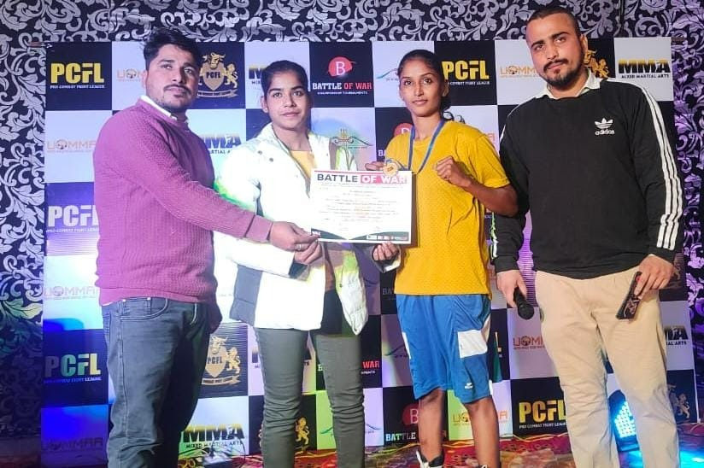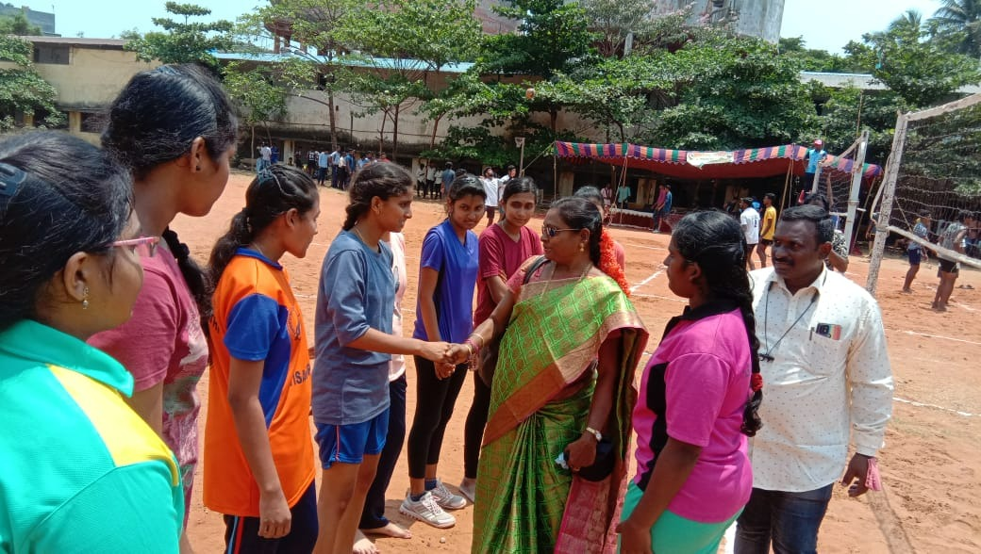
P.kavitha with proffessional boxing champion ship silver medel. Throw Ball team
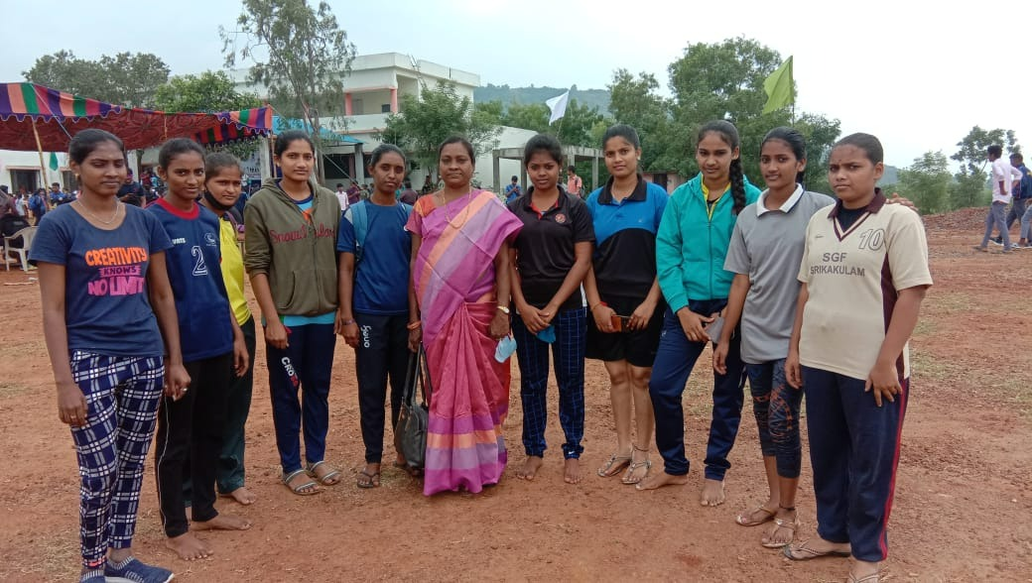
Athletic Team of Dr.VSKGDC( A)

